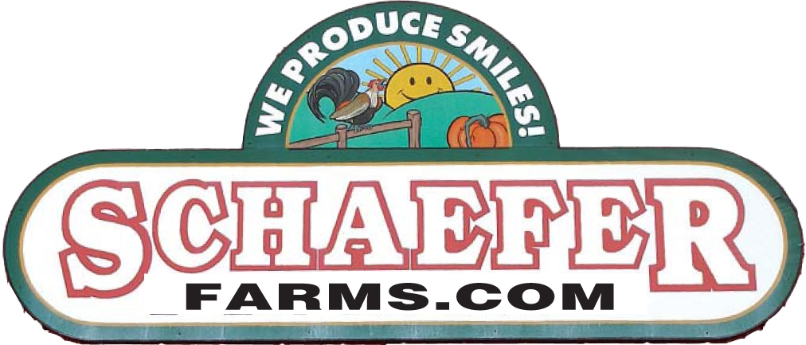

SAUCETOBERFEST 2020
The 5th Annual NJ Hot Sauce Festival
Vendor Application
Saturday September 26, 2020 - 10am - 6pm
Sunday September 27, 2020 10 am - 5pm

Saucetoberfest is an agricultural festival at which we celebrate the harvest of our peppers and fall produce! Support your local Farmer.
No farms No food!
Saucetoberfest Participant Application Rules

- Merchandise and display of participant is subject to the Lessor, Schaefer Farms, who reserves the right to require alteration, replacement and deletions of any material or activity which it deemed inappropriate for festival.
- All vendors will need to bring their own 10' x 10' tent, tables, chairs, coolers, ice and garbage can.
- Each vendor will receive a 12' x 12' area of frontage. Some additional area may be available behind your booth. Additional frontage space can be purchased.
- Vendors will be assigned a specific location designated by area and booth number.There will be no guaranteed booth locations, however every effort will be made to accommodate specific requests. Please be courteous of your fellow vendors by setting up within your designated area.
- Vendor items/products must be pre-approved by the festival committee. The committee may restrict vendors selling products that are similar. Acceptance of your items/products is at the sole discretion of the committee. In the event your items/products are not approved, you will have the right to a full refund. Sauce type vendors are encouraged to supply samples to the crowd.
- Set up time is 4:00pm - 7:00pm on Friday and 7:00am - 9:30am Saturday for All Vendors. All booths need to be set up and ready for business no later than 9:30am Saturday morning and must remain set up for the entire weekend, no leaving early. All vehicles must be moved to the parking lot by this time, No exceptions will be made. A festival representative will be available to help locate vendor assigned booth spaces. Check in at the "Office" upon arrival.
- The festival ends at 5pm on Sunday September 27th. You will not be able to break down your booth until that time. All participants are expected to stay until closing times each day. If you sell out, you may clean up your designated area, but no vehicles may enter the booth area until 5:15pm.
- Each vendor is responsible for their own trash clean up and must provide their own trash cans. Dumpsters will be provided on the grounds, boxes must be broken down and placed in recycling area. Please keep your area clean.
- This is a two (2) day rain or shine event. No Refunds.
- Overnight Camping is available. Tents $10.00, Motor Homes $25.00. A limited amount of electricity and water is available.
- All vendors are responsible for the collection and payment of their own sales tax. All Non-Profits must provide a copy of tax ID Form.
- Overnight security will be provided Saturday night, allowing vendors to leave displays in place. Securing booth contents will be the sole responsibility of each vendor. Schaefer Farms, Saucetoberfest or any of it's affiliates assumes no liability for any lost, stolen or damaged items.
- Limited amount of electricity is availability $30.00 per 110 volt plug.
- Sauce and Packaged Food Vendor Booth Fees: $100.00
- Open Air Table Fee $20.00 (bring your own table) or Rent a table & chair Fee: $35.00
- Political booths, commercial vendors or informational/giveaway booths $350.00.
- Payment must accompany application form. NSF check fee $35.00.
- No beverages or foods may be sold or distributed from any booth except Food Booths.
- Applicants will receive notification of rejection by September 1, 2020. No refund will be made for cancellation or removal for cause.
- Each Vendor will receive four (4) Free parking passes.
- Email applications to saucetoberfest@gmail.com or hard copy to Schafer Farms, 1051 County Rd. Flemington N.J. 08822 Phone: 908-782-2705

